1. Create one VPC,with 1 one public subnet and 1 private subnet.

🡺Create 1 vpc’s and 2 subnets (Pub and Pri) in 2 regions

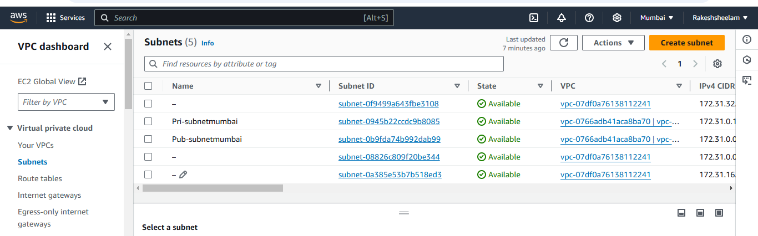

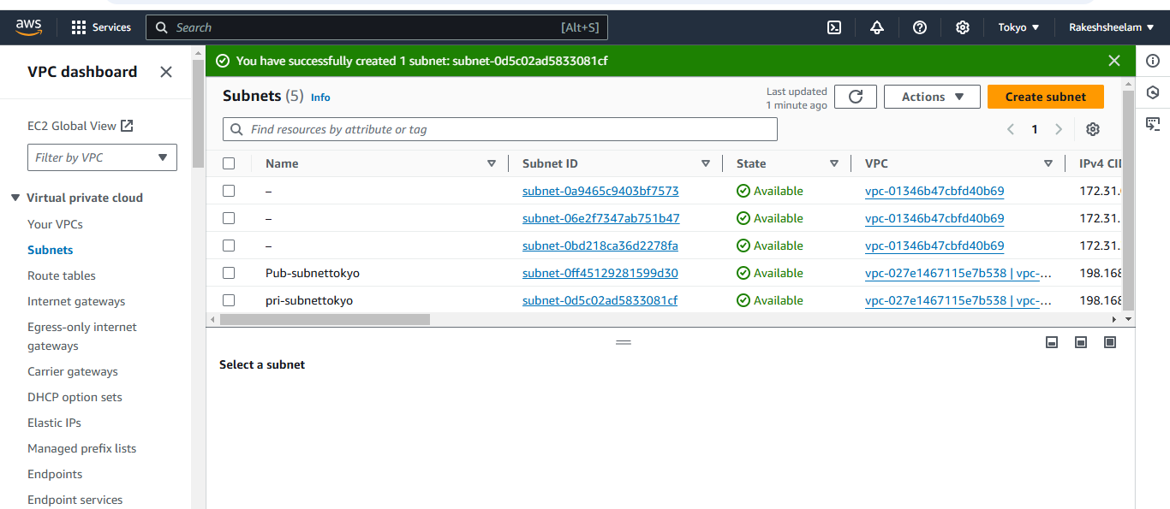

1. Enable VPC peering for cross region.

* Created 2 vpc peering connections between 2 regions from same account.

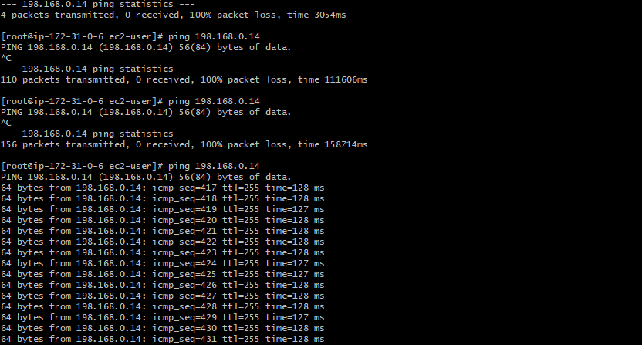

1. Enable VPC peering for cross account. (You can collaborate with your friend and do this task).

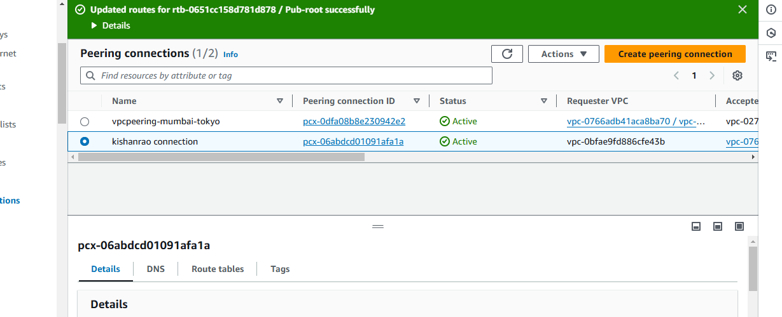

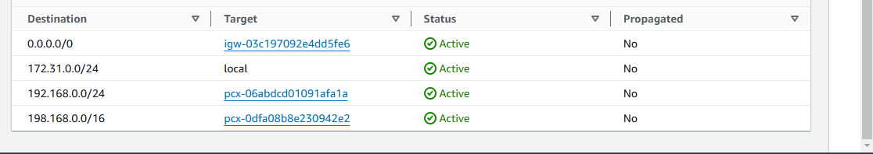

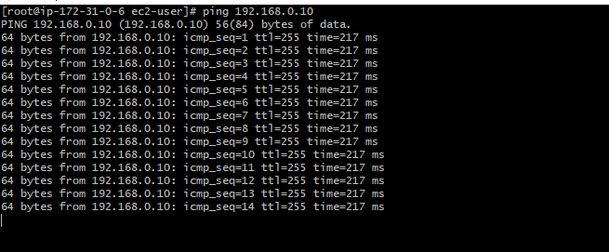

1. Setup VPC Transist gateway.

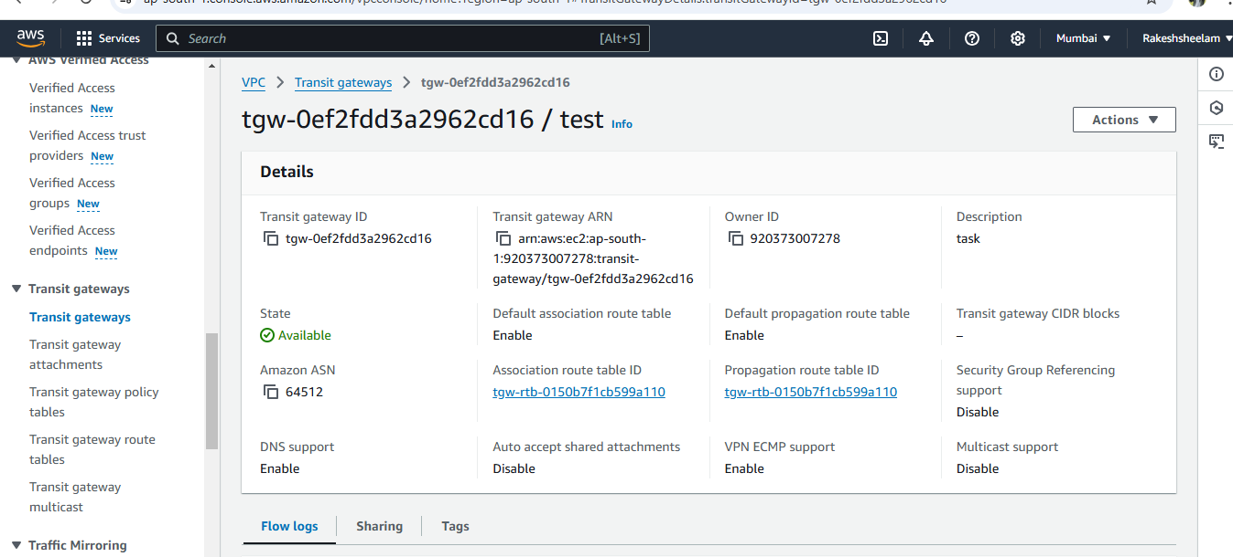

1. Setup VPC End Point.

